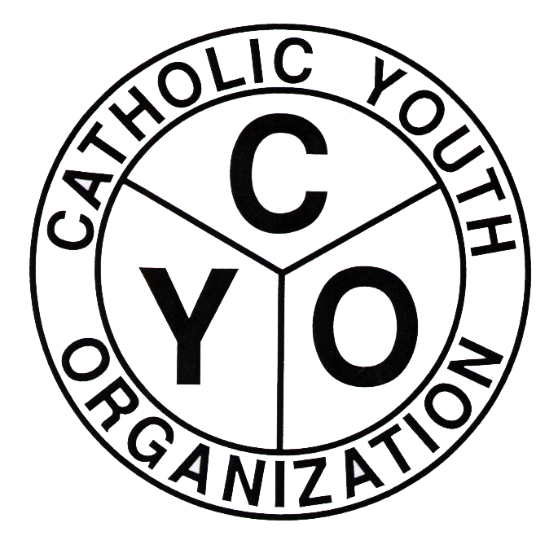
Catholic Youth Organization
of the Diocese of Brooklyn
7200 Douglaston Parkway, Douglaston, NY 11362
Tel: 718.281.9550

FALL 2024 CYO SOCCER ENTRY FORM-BOYS
PARISH: _______________________________________________________________________
Address: ____________________________ City: ______________________ Zip ____________
PLEASE FILL IN THE NUMBER OF TEAMS YOU ARE ENTERING FOR EACH DIVISION
DIVISION Born on or after Number of Teams
Mite 1/1/2018
Squirt 1/1/2017
Subnovice 1/1/2016
Pee-Wee 1/1/2015
Novice 1/1/2014
Bantam 1/1/2013
Rookie 1/1/2012
Intermediate 1/1/2011
ENTRY FEE: $250.00 PER TEAM TOTAL # OF TEAMS: ________TOTAL AMOUNT DUE: _______
PARISH ATHLETIC REPRESENTATIVE ATHLETIC DIRECTOR
NAME ________________________________ _____________________________________
Address _______________________________ _____________________________________
_______________________________ _____________________________________
Home Phone # __________________________ ___________________________
Cell Phone # ____________________________ ___________________________
Email __________________________________ _______________________________________

SCHEDULING CONFLICTS: (PARISH FUNCTIONS MUST BE RELIGIOUS AND/OR EDUCATIONAL)
LIST THE DATES AND TIMES WHEN A PARISH FUNCTION WOULD MAKE IT IMPOSSIBLE TO FIELD A TEAM (BE SPECIFIC FOR EACH TEAM OR ENTIRE PROGRAM).

ENTRY FORMS ARE DUE: AUGUST 19, 2024
COMPLETED ROSTERS ARE DUE: SEPTEMBER 2, 2024
WAIVER REQUESTS ARE DUE: SEPTEMBER 2, 2024
SCHEDULE DISTRIBUTION: AUGUST 27, 2024
*SCHEDULES WILL ALSO BE AVAILABLE ON THE CYO WEBSITE (WWW.CYODOB.ORG)
REGULAR SEASON GAMES WILL BEGIN WEEKEND OF SEPTEMBER 6-8, 2024
COACHES INFO SHEET AND FIELD/COURT AVAILABILITY MUST ACCOMPANY THIS ENTRY FORM.
ENTRY APPROVED BY: PASTOR/MODERATOR SIGNATURE: _________________________________
PAR SIGNATURE: ____________________________________________

